The OPEC Fund for International Development  Parkring 8, A-1010 Vienna, Austria - P.O. Box 995  Tel: +43-1-515 64-0 Fax: +43-1-513 92 38  Email: info@opecfund.org. Website: www.opecfund.org |  |  |  |  |  |  |  |  | Date:
 |  |  |  |  |  |  |  |  | 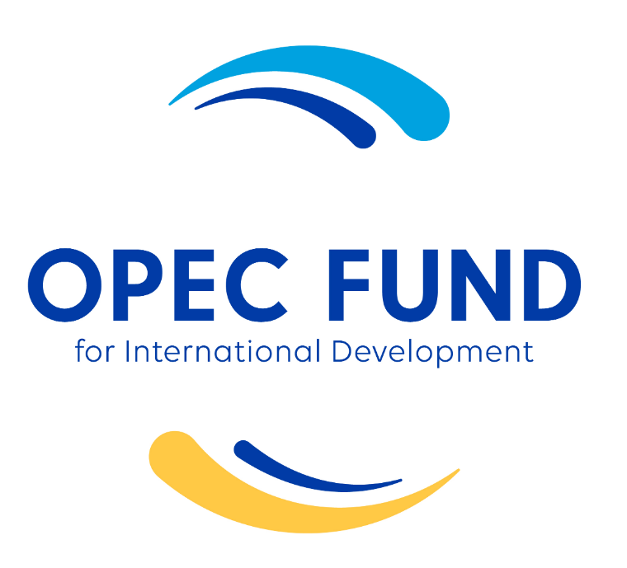

GRANT APPLICATION FORM
- GENERAL INFORMATION ON ORGANIZATION AND PROJECT PROPOSAL

1.1 ORGANIZATION

Full Name & Acronym
Legal Status of the Organization applying for the Grant: Government Agency ☐ / Inter-Governmental Organizations (including UN Agencies) ☐ Other International Non-Government/Not For Profit Organization (i.e. Foundations and Research Centers) ☐ / Private Sector Entity ☐

Date established

Permanent address
Name /Title / Position of Head of Organization
Contact person (incl. Title & Position) in the organization
principal staff who will manage the project and will be the point of contact with the OPEC Fund
City |  |  |  |  | Phone number
State/Province |  |  |  |  | Email
Country |  |  |  |  | Fax number
Registration certificate (required) |  |  |  |  | Website

1.2 PROJECT PROPOSAL
Project title
Sector |  |  |  |  |  | City/Region
Beneficiary country(ies) |  |  |  |  |  | Project Duration (years and months), and the planned start date
Total Project Budget in US$ |  |  |  |  |  | Amount Requested from the OPEC Fund
- DETAILED INFORMATION ON ORGANIZATION
(Brief Introduction on Organization – 10 lines maximum
2.1 Objectives (briefly outline your organization's objectives)
2.2 Organizational Structure, Governance and Staffing
For international organizations, highlight any field presence (regional/country offices) and roles and responsibilities of headquarter and field offices.
Information on staffing is required to assess the capacity of the organization to implement the proposed project.

2.3 Major achievements (Outline any major achievements accomplished during the past 4-5 years)
Highlight in particular track record in implementing similar (in scope, sector, region, country) projects funded by the OPEC Fund and other donors

2.4 Funding Sources
Name |  | Contact details |  |  |  |  |  | Contributions in US$
- EXECUTIVE SUMMARY
please include a brief (one page maximum) abstract of the project
- BACKGROUND AND MAIN RATIONALE OF THE PROPOSED GRANT PROJECT/ACTIVITY
4.1 Background Information on the country(ies) and targeted area(s)
- Relevant information on the country(ies) covered, including selected country socio-economic indicators;
- Information on the target sector(s), including contribution to GDP, employment, governance, organization and financing of the sector, and main challenges and government strategy and policy response;
- Some specific information (population, main economic activities, income and non-income poverty) on targeted project area/s (province/districts), i.e. main economic activities, poverty indicators (income and other indicators) and targeted population.
4.2 Problem analysis
Please specify
- the core problem that the project is expected to address and the constraints
- the root cause of the problem and the effect it is having on the target group(s)

4.3 Main rationale for OPEC Fund support
Contribution to SDGs, alignment with partner country and the OPEC Fund’s mandate and corporate strategy, linkages to the OPEC Fund’s country strategy and operations work program, and added value of the proposed grant project. The latter is particularly relevant in the case of grant components of larger OPEC Fund funded projects and grant activities complementing other OPEC Fund funded interventions. In both cases, the proposal should clearly state how the proposed activity would help deliver the results of the broader OPEC Fund funded intervention. As appropriate, the proposal should state how the proposed intervention could generate or help develop new business opportunities for the OPEC Fund (projects/interventions with potential for scale-up).

4.4 Project Status
This section should clearly state the current status of the project (pre-appraisal, appraisal/design stage or ready for implementation). If the proposed grant is part of a broader OPEC Fund funded investment, also indicate project preparation status. This section should also indicated co-financing status (pledge/expression of interest, firm commitment, agreements signed with other donors or co-financing already available/partly or fully disbursed). Furthermore, it should confirm interest, and approval of the proposed intervention/activity by the authorities of the countries concerned. For grant proposals sponsored by government agencies and UN and inter-governmental organizations, they do not need to provide this letter of approval as it is assumed that the project proponents secured the necessary approvals before submitting their applications.

- PROJECT DESCRIPTION
5.1 Project Goal and Specific Objectives
5.2 Project Main Components/Activities and expected Outputs/Deliverables
Please indicate the products, capital goods and services that result from development interventions
5.3 WBS (Work breakdown Structure)
Please set out a sequence and schedule of activities, sub-activities and tasks required to achieve each output/sub-output
5.4 Project inputs
Please assigned resources (human resources, efforts, equipment, material, facilities, etc.) all non-financial resources required to carry out the project activities
- International or national staff including government recruited, suppliers of special services, consultants and experts
- Physical facilities, basic office premises, equipment and materials, office services, sub-contracting supplies, fellowships, training materials, etc.
5.5 Impact (Direct and indirect Beneficiaries, and other indicators, as appropriate)
5.6 Proposed Project Cost and Financing Plan: the cost should show direct and indirect cost. A more detailed output and activity-based budget should be provided in annex
Component 1 |  |  | Contributions in US$ |  |  |  |  | Name of the co-financier and contact details
Component 2
Component 3
Total Direct Cost
Indirect Cost
Total Cost
- JUSTIFICATION
Considering before, during, and after project implementation; please justify the impacts and necessity of this project
Technical, socio-economic and other project justifications

6.1 Proposed Approach/Strategy to address the issues identified
Please describe
- How and to what extent the identified problem will be addressed and the strategy that will be used to achieve the desired results
- Lessons learned & Complementarities
- Relevant lessons learned from previous interventions in the same field in the country, including those identified through past project evaluations. Explain why they apply and how the project strategy incorporates them
- How the project strategy complements or builds in earlier or ongoing project initiatives, including those undertaken by other organization and by other development partners
- IMPLEMENTATION ARRANGEMENTS
Provide information on proposed implementation arrangements in particular, list and name of main divisions/units within the organization applying for the grant, and external partners that will be directly involved in project management, i.e. monitoring and supervision, and implementation of grant funded activities, clearly defining their respective roles and responsibilities. In addition, provide a clear disbursement and implementation plan, and, as required, a procurement plan. A more detailed implementation framework should be provided in Annex.
- SUSTAINABILITY
Highlight the main specific measures designed for sustaining the project results after the termination of the project
- RISKS and MITIGATION MEASURES
Identify main risks that could affect project implementation and proposed mitigation measures
- KNOWLEDGE MANAGEMENT AND VISIBILITY
Provide information on the proposed arrangements to ensure broad dissemination of project findings and results, e.g. reports, journal articles, conference presentations.
Indicate specific measures aimed to ensure OPEC Fund’s visibility in the partner country.
- RESULTS-BASED LOGICAL FRAMEWORK (to be added as annex)
11.1 Development objective
Please describe
- The expected impact to which the project is expected to contribute
- How will the ultimate beneficiaries be affected by the project
- How the proposal is in line with the sector policy
11.2 Project immediate objective
Please identify clear and measurable objective
11.3 Indicators
Please select S.M.A.R.T. indicators to measure progress towards each objective - to check on performance and progress (of what … )-; set targets for each.
(S.M.A.R.T.: SPECIFIC, measurable, attainable, Relevant and Time-bound)

- DETAILED IMPLEMENTATION PLAN AND FRAMEWORK (to be added as annex)
12.1 Detailed Implementation Plan

12.2 Institutional Framework and Management Arrangements
Institutional analysis: please explain the project adequate institutional support strategy; identify the role of sector partners and potential partnership (including: Govt. , NGOs, Local communities)
- The roles and responsibilities of institutions and partners involved in the project and indicate why they have been selected. Emphasis should be put on government or organizations, agencies and departments.
- A succinct assessment of the existing structure and managerial, financial and technical capacity of the proposed organization that will implement the project, include a description of their strong and weak points, and their experience in dealing with the target group and with similar project.
12.3 Specific Project Management arrangements
Please identify who will oversee the implementation at the project level on a daily basis: composition, name and profile of the staff of the project implementation unit, in particular the project manager and other essential staff such as administration, finance, procurement and other thematic experts
12.4 Monitoring and Evaluation
Please describe developed performance monitoring system and summarize the project M&E system including the processes, procedures and responsibilities foreseen for monitoring and evaluation activities. Specify the frequency and responsibilities for progress reporting
- DETAILED PROJECT BUDGET/COST (to be added as annex)
13.1 The detail activity-based budget and the project implementation period
In accordance with the with the project work breakdown structure. (What is the level and type of inputs required and the unit costs?
a Financial Breakdown Structure should complement the WBS)
See example below:

The project implementation period and the planned starting date
13.2 Tentative financing arrangements
Please describe how you expect the project to be financed: Government Funds, Donors’ fund, Private Sector Investment, PPP, Budgets, Private Foundations, etc. please identify the potential co-financiers and their respective contributions
13.3 Project co-financier(s)
Name |  |  |  | Contact details |  |  |  | Contributions in US$
EXTRA MARK
Any relevant/useful information that is not mentioned earlier

